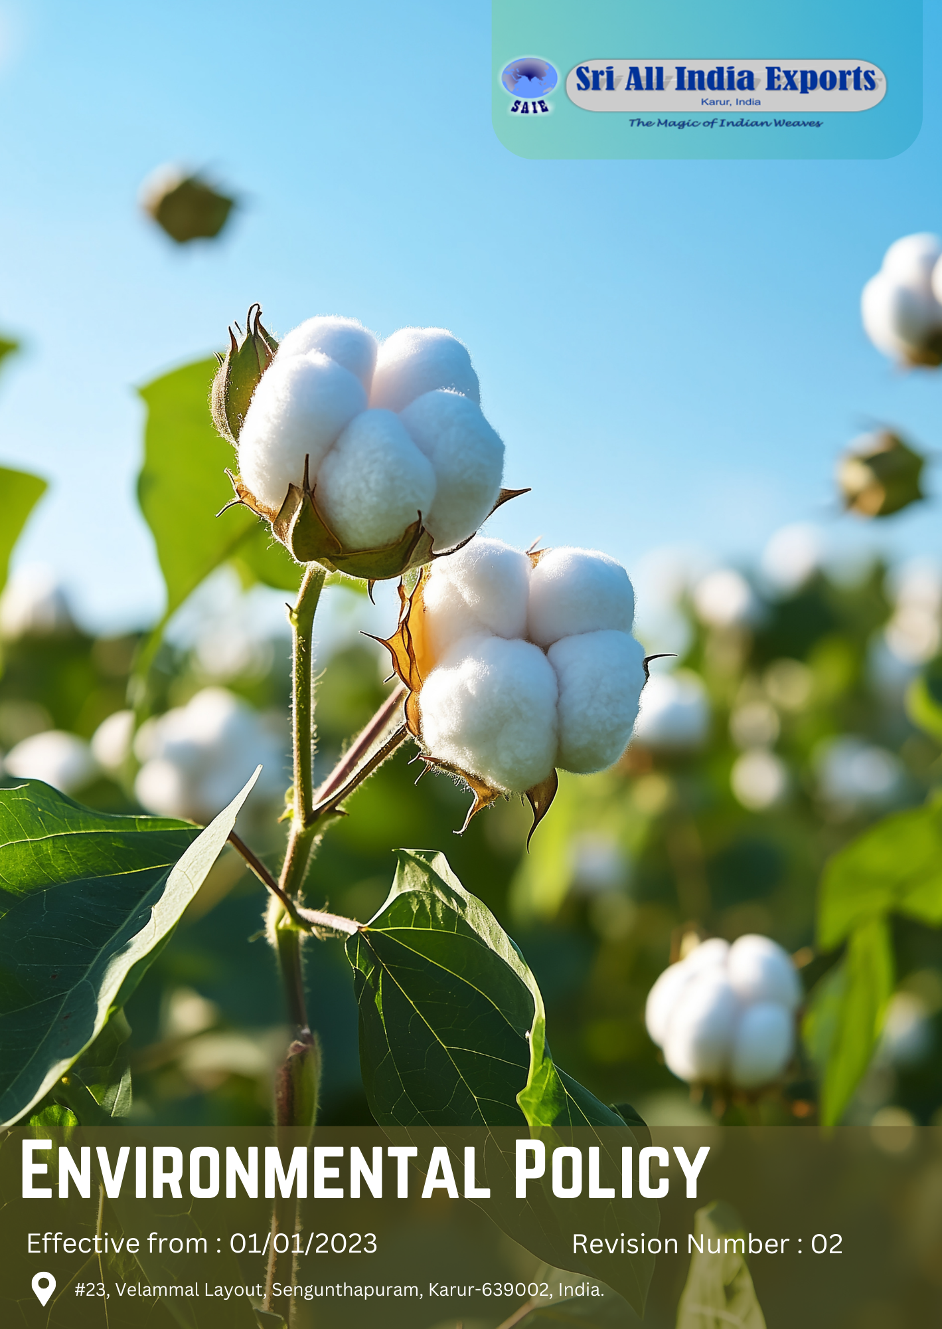

Policy Number

04313

Prepared by

Maria G. White

mariawhite@workerwrite.com
TABLE OF CONTENTS
⧫ INTRODUCTION 2
⧫ SCOPE 2
⧫ POLICY STATEMENT 3
⧫ KEY FOCUS AREA 3
⧫ QUALITATIVE TARGETS 6
⧫ QUANTITATIVE TARGET 9
⧫ CONTINUES IMPROVEMENT 11
⧫ ROLES AND RESPONSIBILITIES: 12
⧫ REPORTING 12
⧫ REVIEW MECHANISM 14
⧫ REVISIONS AND HISTORY 14
⧫ EMPLOYEE ACKNOWLEDGEMENT FORM 15

- INTRODUCTION
Sri All India Exports, is committed to pioneering sustainable practices in the manufacturing of cotton fabrics and home textiles. As an organization deeply rooted in the textile industry for over 41 years, we recognize our responsibility to mitigate environmental impact while delivering high-quality handloom and power loom products to our customers. With a steadfast focus on innovation and efficiency, we aim to lead by example in fostering a greener future for generations to come.

At Sri All India Exports, we understand that the preservation of our planet is paramount. Through strategic policies and initiatives, we seek to minimize our carbon footprint, optimize resource utilization, and promote eco-friendly manufacturing processes. By integrating sustainability into every aspect of our operations, we strive to not only meet regulatory standards but exceed them, setting a new benchmark for environmentally conscious manufacturing in the textile industry. Our commitment to environmental stewardship is not just a policy; it's a fundamental principle driving our vision for a more sustainable tomorrow.

- SCOPE
This policy is exclusively applicable to the operations of Sri All India Exports, covering all employees, workers, subcontractors, and other stakeholders directly affiliated with our site.

Sr. No. | Name of Site | Address
1 | Sri All India Exports | 23, Velammal Layout, Sengunthapuram, Karur-639002, India.

- POLICY STATEMENT
At Sri All India Exports, we are committed to minimizing our environmental footprint through sustainable practices across all stages of cotton fabric manufacturing and home textile production. By prioritizing resource efficiency, waste reduction, and eco-friendly production methods, we aim to contribute positively to the environment and communities we operate in.
- KEY FOCUS AREA
Energy Consumption and Greenhouse gases
- Energy-efficient Processes: Implementing technologies to optimize energy usage in cotton fabric manufacturing processes, reducing overall consumption.
- Renewable Energy Integration: Integrate renewable energy sources like solar power to reduce reliance on non-renewable energy.
- Optimized Equipment: Upgrade machinery and equipment to energy-efficient models, reducing energy consumption in both handloom and power loom operations.
Water
- Water Recycling: Developing innovative systems to recycle water used in fabric dyeing and finishing processes, enhancing efficiency and reducing water consumption.
- Filtration Optimization: Enhancing filtration systems within textile manufacturing operations to effectively remove impurities and minimize water wastage.
- Rainwater Harvesting: Incorporating rainwater harvesting systems to capture and utilize rainwater for industrial processes, reducing dependence on freshwater sources.
Biodiversity
- Sustainable Cotton Sourcing: Ensuring our cotton is sourced from suppliers who practice sustainable agriculture and protect local ecosystems.
- Habitat Preservation: Implementing measures to safeguard natural habitats in cotton-growing regions and around our manufacturing sites.
- Ecosystem Restoration: Actively participating in ecosystem restoration projects to offset any environmental footprint generated during manufacturing processes.

Air Pollution
- Emission Control Measures: Implementing advanced filtration systems to minimize harmful emissions during textile manufacturing processes.
- Noise Reduction Strategies: Developing soundproofing solutions and scheduling production activities to mitigate noise pollution generated by machinery and operations within the textile manufacturing facility.
- Install state-of-the-art air filtration systems to capture and reduce emissions from textile production processes, ensuring compliance with environmental standards

Material Chemical and Waste
- Sustainable Material Selection: Prioritize eco-friendly materials and dyes to minimize environmental impact and promote sustainability in textile manufacturing processes.
- Chemical Management: Implement strict protocols for chemical handling, storage, and disposal to prevent pollution and ensure worker safety.
- Waste Reduction: Develop strategies to minimize both hazardous and non-hazardous waste generation through efficient textile production practices.
- Recycling Initiatives: Promote the reuse and recycling of textile waste and by-products to reduce landfill burden and conserve resources.

Environmental impacts from use of products
- Sustainable Sourcing: Ensuring that raw materials used in textile production are responsibly sourced and have minimal environmental impact.
- End-of-Life Management: Implementing strategies for the proper disposal, recycling, or repurposing of textile products to minimize waste and environmental harm.
- Durability and Longevity: Promoting the design and manufacture of durable textile products to extend their lifespan and reduce the frequency of replacement.

Environment Impact from Product End-of-Life
- Waste Management: Implementing efficient recycling and disposal methods to minimize waste from textile products at the end of their lifecycle.
- Material Recovery: Promoting initiatives for reclaiming valuable materials from used textile products to reduce environmental strain.
- Lifecycle Assessment: Conducting comprehensive assessments to understand the environmental impacts of our textile products throughout their lifecycle.

Customer Health and Safety
- Non-toxic Materials: Prioritize non-toxic dyes and finishes to minimize health risks associated with textile manufacturing processes and end products.
- Product Testing: Conduct rigorous testing procedures to certify product safety and compliance with health regulations before market release.
- Worker Training: Provide comprehensive training on handling materials and equipment to ensure employee safety and well-being.

Promotion of Sustainable Consumption
- Eco-friendly Product Lines: Develop and promote eco-friendly textile product lines using organic cotton and sustainable production methods.
- Consumer Education: Educate consumers about the environmental benefits of sustainable textiles and proper care to extend product life.
- Supply Chain Transparency: Ensure transparency in the textile supply chain to trace the origin and sustainability of raw materials.
Environmental services and advocacy
- Community Engagement: Develop and implement environmental education programs for local communities and schools.
- Industry Leadership: Take a leading role in promoting sustainable practices within the textile industry through participation in industry forums and associations.
- Government Collaboration: Work with local and national government bodies to advocate for and support environmentally friendly policies in the textile sector
- QUALITATIVE TARGETS
Energy consumption and Greenhouse Gases
- Implement energy-efficient dyeing and finishing processes to reduce overall energy consumption in textile manufacturing. For example, installing heat recovery systems in our dyeing units to capture and reuse waste heat.
- Gradually transition to renewable energy sources, particularly solar power, for our manufacturing facilities. This could involve installing solar panels on the rooftops of our Karur factory.
- Optimize handloom and power loom operations through the adoption of energy-efficient machinery and production techniques, such as replacing old power looms with modern, energy-efficient models.
Water
- Develop and implement water recycling systems for dyeing and finishing processes to minimize freshwater consumption. For instance, installing a reverse osmosis plant to treat and reuse wastewater from our dyeing units.
- Enhance wastewater treatment facilities to improve water quality and enable safe reuse in manufacturing processes, such as upgrading our existing effluent treatment plant with advanced biological treatment methods.
- Implement rainwater harvesting systems to supplement water needs and reduce dependency on municipal water supply, for example, by installing rainwater collection systems on factory roofs and in open areas.

Biodiversity
- Partner with cotton suppliers who adhere to sustainable farming practices and protect local ecosystems. This could involve sourcing cotton from farms that use organic farming methods and avoid harmful pesticides.
- Implement green spaces and native plant species around our manufacturing facilities to support local biodiversity, such as creating a butterfly garden with local flora on our factory premises.
- Engage in community-based reforestation and habitat restoration projects in the Karur region, for example, by adopting a local water body and planting native trees along its banks.

Air Pollution
- Install advanced air filtration systems in our manufacturing units to reduce emissions from textile production processes. For instance, implementing electrostatic precipitators in our boiler stacks.
- Transition to low-emission vehicles for transportation of goods and encourage carpooling among employees. This could involve replacing our diesel trucks with electric or CNG vehicles for local transportation.
- Implement noise reduction measures in our facilities to minimize impact on surrounding communities, such as installing sound-absorbing panels in noisy areas of the factory.

Material Chemical and Waste
- Transition to eco-friendly, biodegradable dyes and chemicals in our textile production processes. For example, replacing azo dyes with natural dyes derived from plants for certain product lines.
- Implement a comprehensive waste segregation and recycling program across all our operations, such as setting up color-coded bins for different types of textile waste in our production areas.
- Develop innovative ways to repurpose textile waste into new products or materials, like creating home decor items from fabric scraps.
Environmental impacts from use of products
- Design products with longevity in mind, using durable materials and construction techniques. For instance, reinforcing seams in our bed linens to increase their lifespan.
- Provide customers with guidelines for environmentally friendly care and maintenance of our textile products, such as including wash care labels that promote low-temperature washing and line drying.
- Develop a take-back program for used textile products to ensure proper recycling or disposal, like offering customers a discount on new purchases when they return old bedsheets or curtains.

Environment Impact from Product End-of-Life
- Establish partnerships with textile recycling facilities to ensure proper handling of end-of-life products. For example, collaborating with a local recycling company to process our cotton waste into new yarn.
- Research and implement innovative techniques for textile upcycling and material recovery, such as developing a line of patchwork quilts made from end-of-life bed linens.
- Conduct regular life cycle assessments of our products to identify areas for environmental improvement, for instance, analysing the carbon footprint of our cotton towel production from farm to disposal.
Customer Health and Safety
- Phase out the use of harmful chemicals and transition to safer alternatives in all our textile products. For example, replacing formaldehyde-based wrinkle-resistant treatments with citric acid-based alternatives.
- Implement rigorous quality control and safety testing protocols for all products before market release, such as conducting allergen tests on all our bed linen products.
- Provide transparent product information to customers regarding materials used and their environmental impact, like including a QR code on product tags that links to detailed sustainability information.

Promotion of Sustainable Consumption
- Launch a line of eco-friendly textile products made from organic and recycled materials. For instance, introducing a range of towels made from a blend of organic cotton and recycled PET bottles.
- Develop educational materials for customers on the benefits of sustainable textiles and their proper care, such as creating video tutorials on how to extend the life of home textiles.
- Implement a transparent supply chain tracking system to allow customers to trace the origin of their products, like developing a mobile app where customers can input a product code to see its journey from cotton field to store.

Environmental Services and Advocacy
- Establish a comprehensive environmental education program for local schools and communities. For example, creating a "Textile Sustainability Workshop" series that covers topics like water conservation, recycling, and sustainable fashion.
- Actively participate in textile industry associations to promote sustainable practices. This could involve joining the Sustainable Apparel Coalition and contributing to the development of industry-wide sustainability standards.
- Collaborate with local government on environmental initiatives. For instance, partnering with the Karur Municipal Corporation to implement a textile waste recycling program in the city.
- QUANTITATIVE TARGET
Energy consumption and Greenhouse Gases
- Reduce overall energy consumption in manufacturing by 15% by 2030 from the baseline year 2022.
- Achieve 20% renewable energy usage in operations by 2030 from the baseline year 2022.
- Decrease greenhouse gas emissions by 15% by 2030 from the baseline year 2022.
Water
- Reduce water consumption in textile manufacturing by 30% by 2030 from the baseline year 2022.
- Achieve 30% water recycling and reuse in our processes by 2030 from the baseline year 2022.
- Implement rainwater harvesting to meet 15% of our water needs by 2030 from the baseline year 2022.
Biodiversity
- Source 60% of our cotton from certified sustainable farms by 2030 from the baseline year 2022.
- Increase green cover in and around our facilities by 25% by 2030 from the baseline year 2022.

Air Pollution
- Reduce air pollutant emissions from our manufacturing processes by 20% by 2030 from the baseline year 2022.
- Decrease carbon emissions from transportation by 15% by 2030 from the baseline year 2022.
- Achieve a 30% reduction in noise levels from our operations by 2030 from the baseline year 2022.

Material Chemical and Waste
- Transition 50% of our dyes and chemicals to eco-friendly alternatives by 2030 from the baseline year 2022.
- Achieve a 30% reduction in waste sent to landfills by 2030 from the baseline year 2022.
- Recycle or repurpose 40% of our textile waste by 2030 from the baseline year 2022.

Environmental impacts from use of products
- Increase the average lifespan of our products by 25% by 2030 from the baseline year 2022, through improved durability.
- Achieve 80% recyclability in our product range by 2030 from the baseline year 2022.
- Reduce the carbon footprint of our products by 20% through lifecycle improvements by 2030 from the baseline year 2022.

Environment Impact from Product End-of-Life
- Establish a take-back and recycling program for 40% of our product range by 2030 from the baseline year 2022.
- Achieve a 30% material recovery rate from end-of-life products by 2030 from the baseline year 2022.
- Conduct lifecycle assessments on 100% of our product range by 2030 from the baseline year 2022.

Customer Health and Safety
- Eliminate 100% of harmful chemicals from our products by 2030 from the baseline year 2022.
- Achieve third-party safety certifications for 80% of our product range by 2030 from the baseline year 2022.
- Reduce customer complaints related to product safety by 50% by 2030 from the baseline year 2022.

Promotion of Sustainable Consumption
- Increase the share of eco-friendly products to 50% of our total product range by 2030 from the baseline year 2022.
- Achieve 100% supply chain transparency for our premium product lines by 2030 from the baseline year 2022.

Environmental Services and Advocacy
- Implement environmental education programs in 80% of local schools and communities by 2030 from the baseline year 2022.
- Participate in 15 industry sustainability initiatives and forums annually by 2030 from the baseline year 2022.
- Collaborate with local governments on 10 environmental initiatives by 2030 from the baseline year 2022.
- Provide sustainability training to 100% of our employees and suppliers by 2030 from the baseline year 2022.
- CONTINUES IMPROVEMENT
Sri All India Exports is committed to fostering a culture of continuous improvement in environmental practices within our textile manufacturing processes. We recognize the importance of minimizing our ecological footprint and are dedicated to implementing strategies that enhance sustainability. Through regular assessments and evaluations, we aim to identify areas where we can reduce waste, conserve resources, and mitigate environmental impact.
Our environmental policy focuses on integrating innovative technologies and best practices to optimize efficiency and minimize emissions. We prioritize the development of eco-friendly materials and processes while ensuring compliance with all relevant regulations and standards. By fostering a collaborative approach and promoting environmental awareness among our employees, suppliers, and stakeholders, we strive to achieve our goals of sustainability and responsible stewardship of the environment. Through ongoing monitoring and adaptation, we are committed to continually improving our environmental performance and contributing to a greener, more sustainable future in the textile industry.
- ROLES AND RESPONSIBILITIES:
- Environment Safety Officer: Oversees the implementation of this policy, ensures compliance with Environment regulations, and reports on progress.
- Environment Task Force: A cross-functional team monitors day-to-day implementation of Environment initiatives.
- Board of Directors: Oversees implementation of this policy, ensuring alignment with the company's overall strategy.
- Employees: Receive annual training on Environment responsibilities and are encouraged to contribute ideas for improving performance.

- REPORTING
At Sri All India Exports, we recognize the importance of transparent and comprehensive reporting on our environmental initiatives and performance. Our reporting mechanism is designed to provide clear, accurate, and timely information to all stakeholders, including employees, customers, investors, and regulatory bodies. The key components of our reporting system are as follows:

- Environmental Performance Metrics:
- Conduct monthly assessments of key environmental indicators, including energy consumption, water usage, waste generation, and carbon emissions.
- Utilize advanced monitoring systems, such as smart meters for energy and water consumption, to ensure accurate and real-time data collection.
- Compile quarterly reports comparing current performance against baseline data and targets set in our environmental policy.

- Annual Sustainability Report:
- Publish a detailed annual sustainability report that provides a comprehensive overview of our environmental initiatives, achievements, challenges, and future plans.
- Include case studies of successful projects, such as our water recycling system implementation or community tree planting initiatives.
- Have the report independently verified by a third-party environmental auditor to ensure credibility and transparency.

- Supply Chain Transparency Reports:
- Conduct bi-annual assessments of our suppliers' environmental practices and compile reports on the sustainability of our supply chain.
- Include information on the percentage of sustainably sourced materials, supplier compliance with our environmental standards, and areas for improvement.

- Environmental Incident Reporting:
- Establish a robust system for reporting and addressing any environmental incidents or near-misses.
- Provide monthly summaries of any incidents, including root cause analysis and corrective actions taken.

- Carbon Footprint Disclosure:
- Calculate and report our carbon footprint annually, following internationally recognized standards such as the Greenhouse Gas Protocol.
- Provide a breakdown of emissions by scope (Scope 1, 2, and 3) and by business activity.

- Community and Stakeholder Engagement Reports:
- Document our environmental education and community outreach activities, including the number of people reached and the impact of these initiatives.
- Compile feedback from stakeholders on our environmental performance and initiatives.

- REVIEW MECHANISM
The Environmental Safety Office is responsible for the implementation, oversight, and review of this policy. This Policy will be reviewed every year, and any updates will be communicated as necessary.
- REVISIONS AND HISTORY
Revision. No | Review Date | Changes Made
00 | 01-Jan-2023 | Initial release of the document
01 | 01-Jan-2024 | Initial review of the document
02 | 01-Jan-2025 | Added Roles and responsibilities section; included revision history table


L.Shanthi S.P.Selvam
Prepared By: Environmental Safety Office Approved By: General Manager
Next Review Date: 01/01/2026
- EMPLOYEE ACKNOWLEDGEMENT FORM
I, hereby acknowledge that I have received, read, and understood the Environmental Policy of Sri All India Exports. I understand the importance of this policy and my responsibility to adhere to and uphold the environmental standards and practices outlined within it.

By signing this form, I commit to:
- Complying with all environmental policies and procedures.
- Actively participating in the environmental initiatives and programs implemented by Sri All India Exports.
- Contributing to the continuous improvement of our environmental performance.
- Reporting any environmental incidents or concerns to the Environmental Safety Office.

I understand that failure to adhere to the environmental policy may result in disciplinary action, up to and including termination of employment.
- Employee Confirmation:
Employee Signature: __(C.Rajarjan)
Date: 25.08.25
- Supervisor Confirmation
I confirm that the above employee has received, read, and understood the Environmental Policy of Sri All India Exports.

Supervisor Signature: __M.Mahesh

Date: 25.08.25

